Computing in Epidemiology and Biostatistics
Find the maximum likelihood estimates for a logistic regression
Wan-Yu Lin

Newton-Raphson method for root-finding for 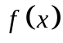: (two weeks ago)
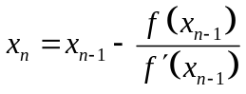
Newton-Raphson method for root-finding for 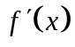: (one week ago)
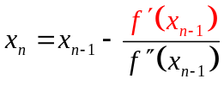
High-dimensional Newton-Raphson method for root-finding for 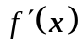: (this week)
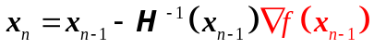

High-dimensional Newton-Raphson method
The gradient of 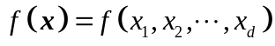:
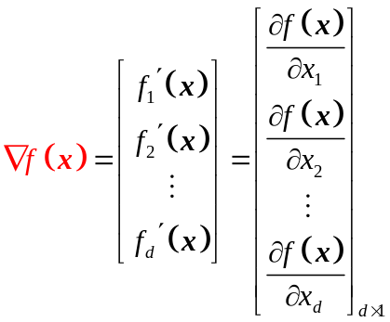
The first derivative of 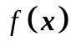 with respect to 
The first derivative of with respect to 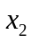
The first derivative of with respect to 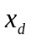

Distance between 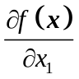 and 0 would be 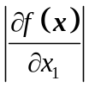.
Distance between 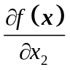 and 0 would be 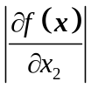.
Distance between 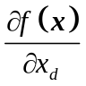 and 0 would be 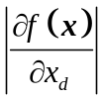.

Hessian matrix of :
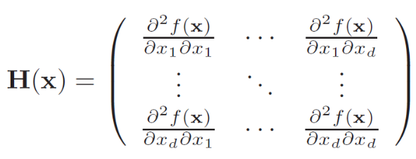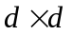
is a square matrix of second-order partial derivatives of .

# High-dimensional Newton-Raphson method, starting at x0
# ftn is a function that given x returns the list {gradient of f(x), Hessian matrix of f(x)}, for some f(x)

newtonraphson <- function(ftn, x0, tol = 1e-9, max.iter = 100) {
x <- x0 # x0: the initial value
fx <- ftn(x)
iter <- 0
while ((max(abs(fx[[1]])) > tol) & (iter < max.iter)) {
x <- x - solve(fx[[2]]) %*% fx[[1]]
fx <- ftn(x)
iter <- iter + 1
}
if (max(abs(fx[[1]])) > tol) {
cat('Algorithm failed to converge\n')
return(NULL)
} else { # max(abs(fx[[1]])) <= tol
cat("Algorithm converged\n")
return(x)
}
}

Ex 20：Data: admit.txt please read it into R and call it “admit” object：
- Please use the Newton-Raphson method to find the maximum likelihood estimate (MLE) of the regression coefficients of logistic regression (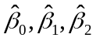), and compare your result with the R built-in function glm(admit~gpa+gre, family=binomial, data=admit)
- Please find the variance-covariance matrix for , and compare your result with the R built-in function vcov(model)
- Please find the log likelihood at , and compare your result with the R built-in function logLik(model)

[PS]

Variance-covariance matrix for is 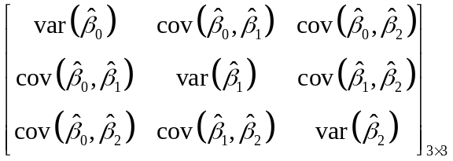. We don’t like it too large, which represents your estimation for MLE is not stable.

A larger sample size will lead to a smaller variance-covariance matrix for .
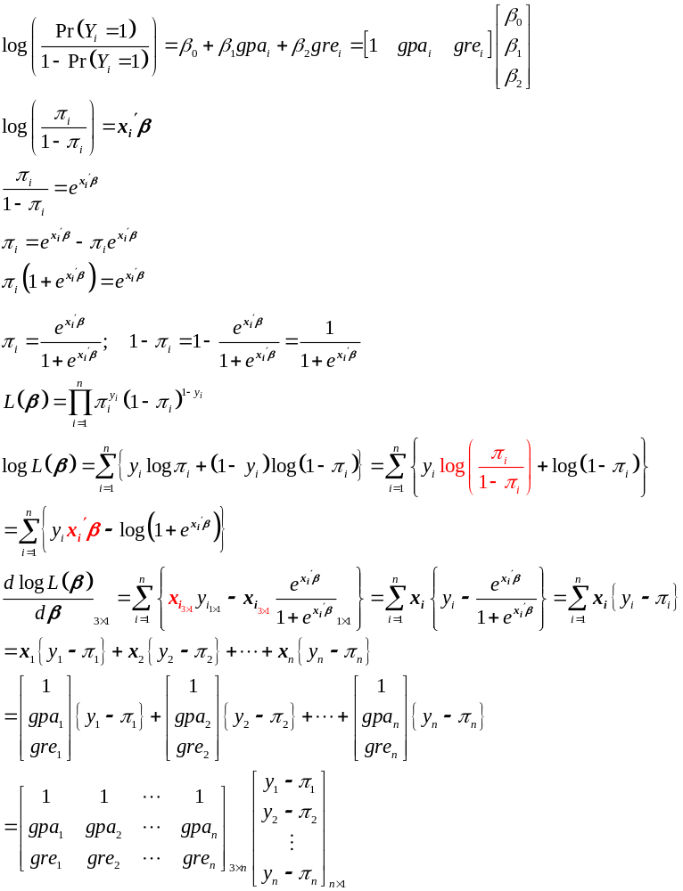
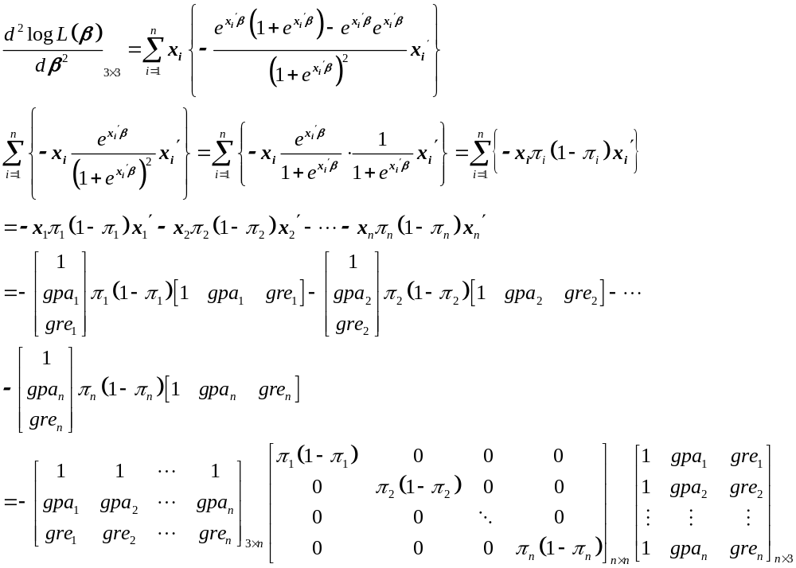
Constructing the design matrix:

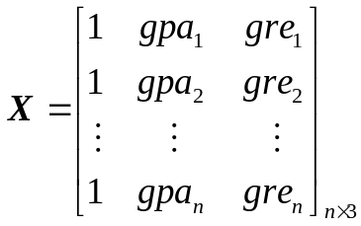

Building 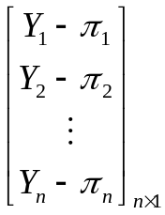

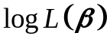

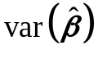 larger smaller

gradient
0
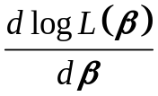

Hessian matrix
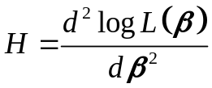 -1/3 -1
(just take two real numbers, -1/3 and -1, as examples. It’s always easier for us to think from real numbers.)

 1/3 1

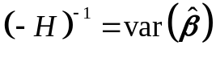 3 1
(There is a strict proof in mathematical statistics. Because this course is not mathematical statistics, we provide a simple and intuitive way to connect the Hessian matrix to .)

Homework: (8 points, please pay attention to all the words in this orange box):

Ex 20-1：Data: resp.csv please read it into R and call it “resp” object：
- Please use the Newton-Raphson method to find the maximum likelihood estimate (MLE) of the regression coefficients of logistic regression (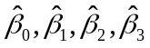). (4 points)
Please note: No need to make a plot for the initial value. Using the R built-in function “glm(outcome~treatment+age+baseline, family=binomial, data=resp)” to answer this homework will be scored as 0, although you may use it to check your own answer.
- Please find the variance-covariance matrix for . (2 points)
Please note: Using the R built-in function “vcov(model)” to answer this homework will be scored as 0, although you may use it to check your own answer.
- Please find the log likelihood at . (2 points)
Please note: Using the R built-in function “logLik(model)” to answer this homework will be scored as 0, although you may use it to check your own answer.

